- Looks like the header image does not match the copy deck direction:
F296GTM_hero_shots_3_4_16_9_v11_e8a3fe45-ebaf-4e15-b69d-cd513e92ef05
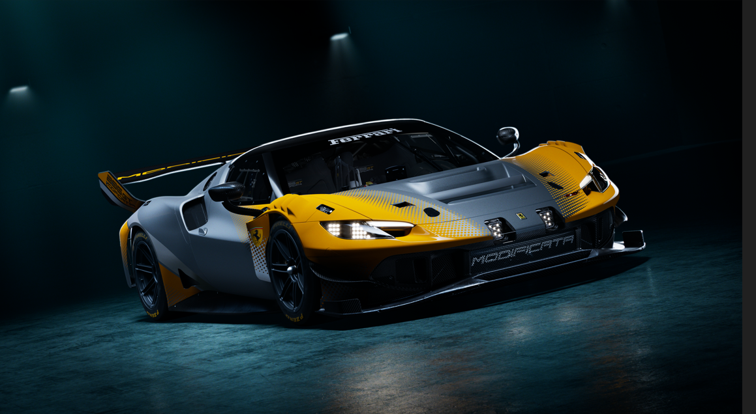

- Let’s remove this second line:

- Can you confirm where the CTA will go? Usual inquiry form?
- Module 1 should have image:
F296GTM_details_v06_005_16_9_61994701-b821-4a78-a416-df33a7ffe4c7
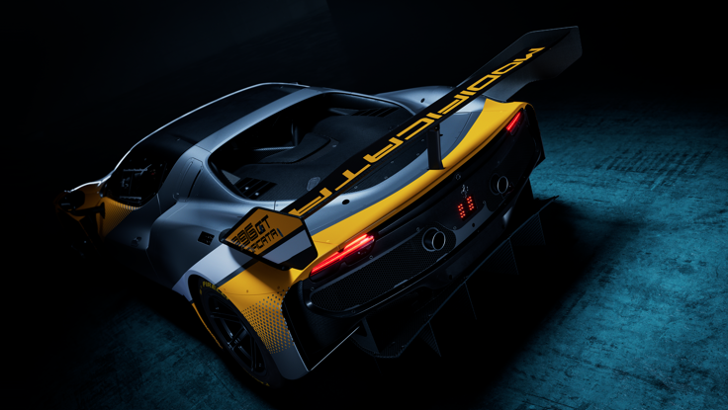

- Aerodynamics should have image:
F296GTM_hero_shots_front_v11_16_9_e712d706-e809-4fcb-b6a0-3481d18cf8f0
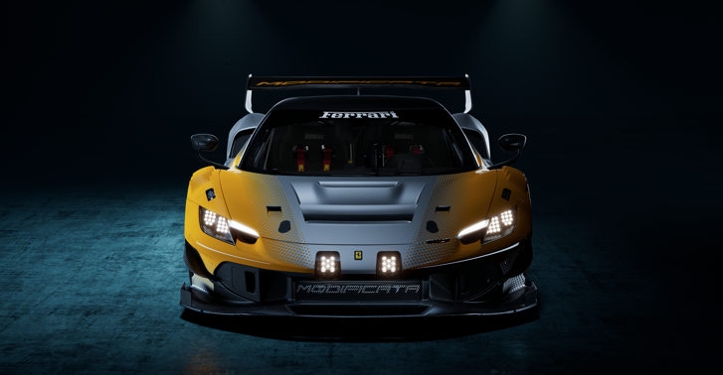

- We are missing the section number and naming for Equipment and Options.
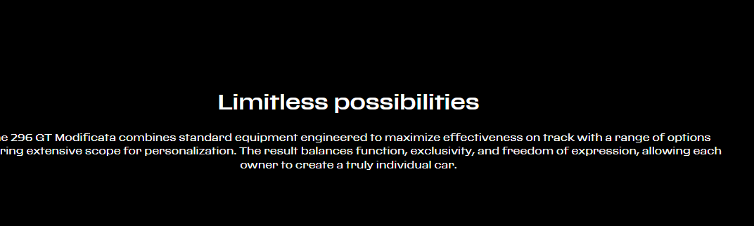

- Image to be used for Limitless possibilities should be:
F296GTM_hero_shots_back_16_9_v11_56de07dc-902f-42af-b31d-2a217b44a627
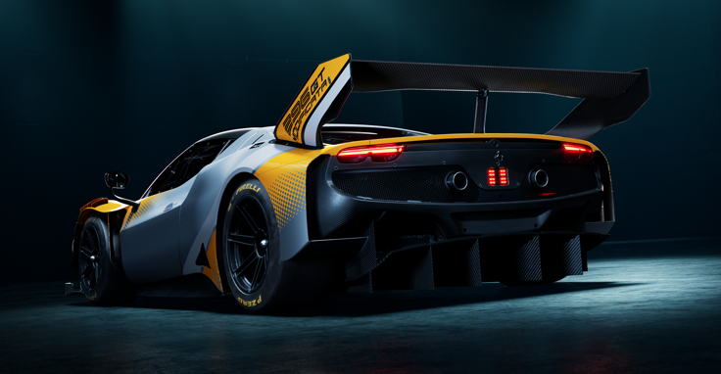

- Missing image for last Module
F296GTM_details_v06_002_16_9_662c39c8-3d38-4581-8350-fae08c010d13
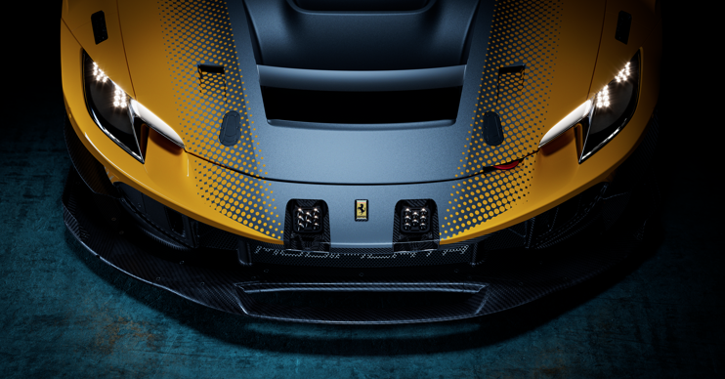

- Where are the specs under “The Power Unit” and “The Programme” coming from?

